MD. Rajaul Ansari

**Boolean Expressions**

**Task:**

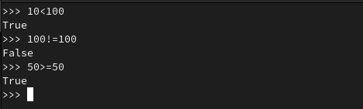

**Task:**

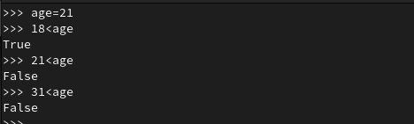

**Task:**

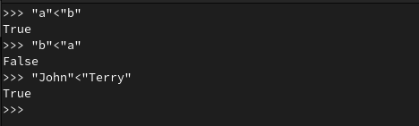

**Task:**

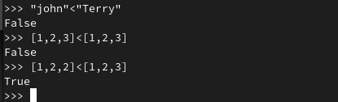

**Task:**

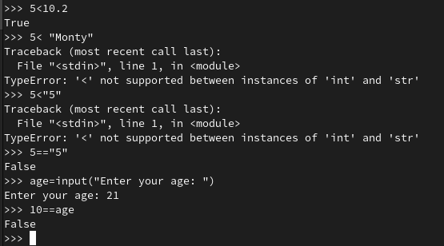

**Logical Operators within Expressions**

**Task:**

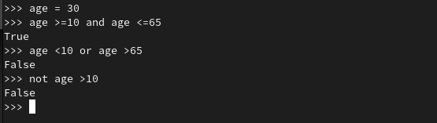

**Task:**

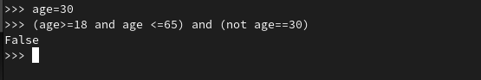

**Chaining relational operators**

**Task:**

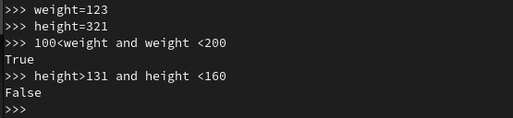

**Membership Testing**

**Task:**

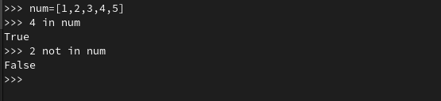

**The ‘if’ statement**

**Task:**

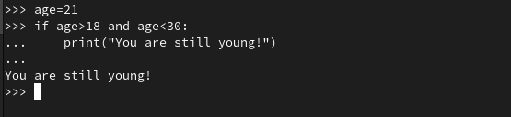

**Using the ‘else’ and ‘elif’ clause**

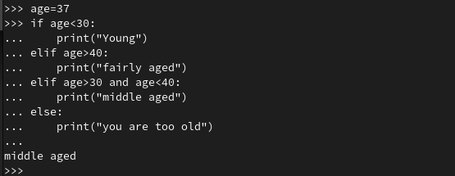

**Non-boolean conditions**

**Task:**

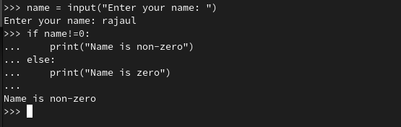

**The Ternary Operator**

**Task:**

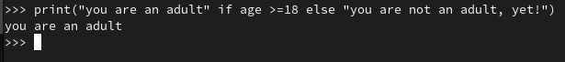

**Using ‘while’ and ‘for’ loops**

**Task:**

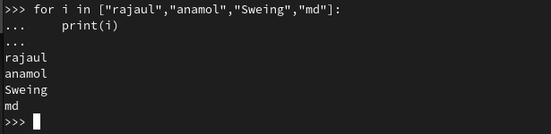

**The range() function**

**Task:**

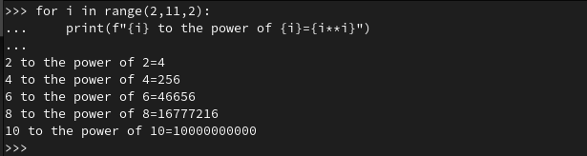

**Using ‘continue’ within a loop**

**Task:**

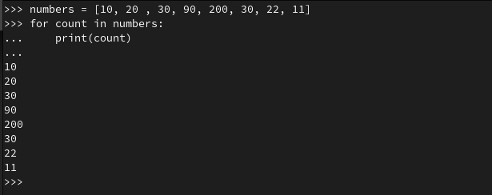

**Task:**

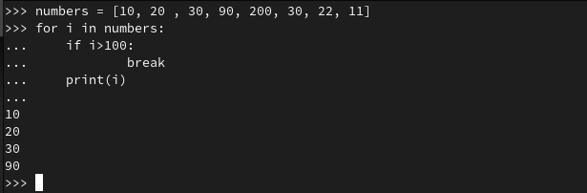

**Task:**

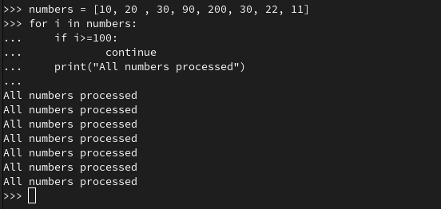

**Key Terminology**

**Boolean Expression:** Boolean expression is an [expression](https://en.wikipedia.org/wiki/Expression_(programming)) used in [programming languages](https://en.wikipedia.org/wiki/Programming_language) that produces a [Boolean value](https://en.wikipedia.org/wiki/Boolean_value) when evaluated. A Boolean value is either true or false.

**Relational Operator:** Relational operators compare numeric, character string, or logical data. The result of the comparison, either true ( 1 ) or false ( 0 ), can be used to make a decision regarding program flow (see the IF statement).

**Logical Operator:** Logical operators that can only be used with expressions whose results are logical values (i.e., .True. or .False.).

**Operator Chaining:** Checking more than two conditions.

**Ternary Operator:** Ternary operators are also known as conditional expressions are operators that evaluate something based on a condition being true or false.

**Iteration:** An iterator is an object that can be iterated upon, meaning that you can traverse through all the values.

**Nested Loop:** A nested loop is a loop inside the body of the outer loop.